**TASK 8**

Simple Sales Dashboard Design

**Objective:**

Create a basic interactive dashboard that shows sales performance by product, region, and month.

**🛠 Tools:**

Power BI or Tableau (choose one)

(Optional: Python + Pandas for cleaning)

**📁 Dataset:**

Superstore_Sales.csv (Columns: Order Date, Region, Category, Sales, Profit)/ ANY DATA SET

📦 **Deliverables:**

1 screenshot or PDF export of the dashboard

3–4 insights written in a text file or slide

**📌 Steps (Mini Guide**):

1.Import the CSV file into Power BI or Tableau

2.Convert Order Date to “Month-Year” format

3.Add 2–3 visuals:

Line Chart: Sales over Months

Bar Chart: Sales by Region

Donut Chart: Sales by Category

4.Add a filter/slicer for Region or Category

5.Use colors to highlight top-performing areas

6.Write 3 short insights (example: “West region had the highest sales in Q3”)

1.Import the CSV file into Power BI

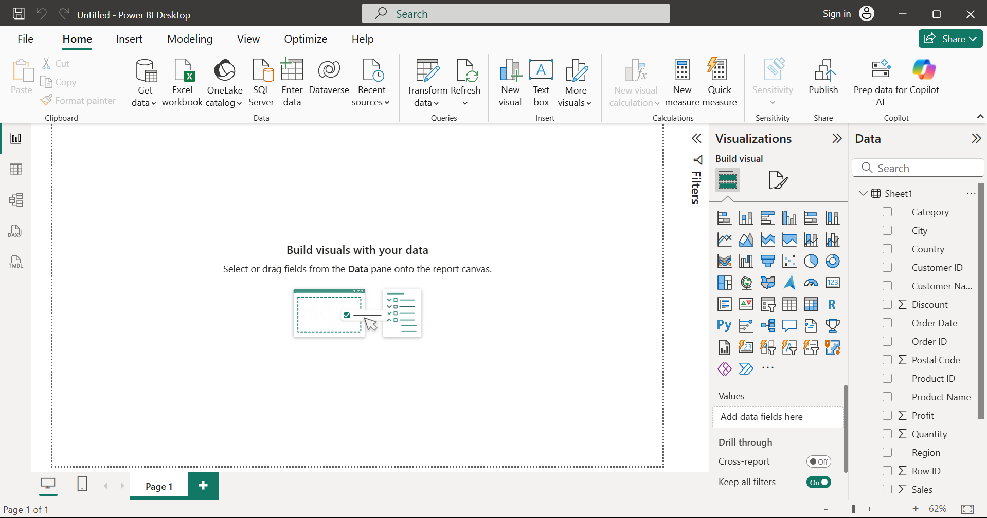

2.Convert Order Date to “Month-Year” format

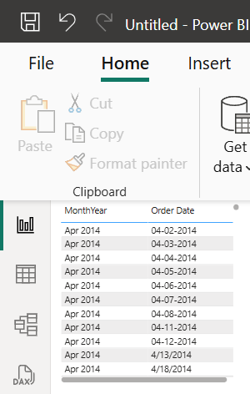

Go to **Modeling → New column** and paste this:

MonthYear = FORMAT(DATEVALUE('Orders'[Order Date]), "MMM YYYY")

3.Add 2–3 visuals:

Line Chart: Sales over Months

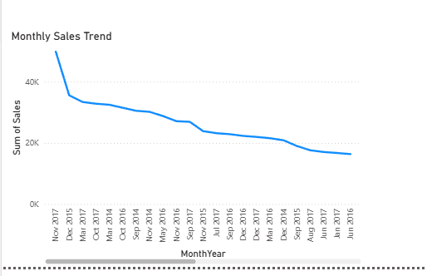

Bar Chart: Sales by Region

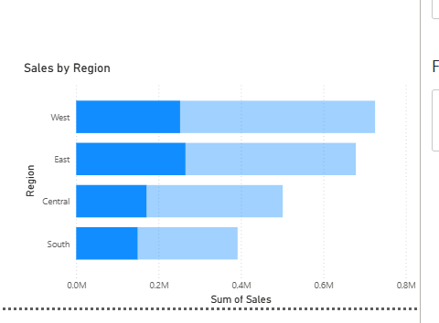

Donut Chart: Sales by Category

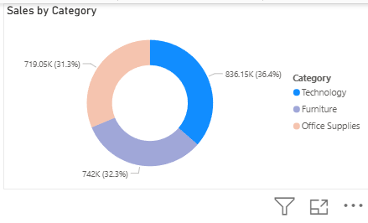

4.Add a filter/slicer for Region or Category

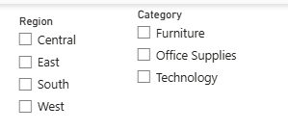

5.Use colors to highlight top-performing areas

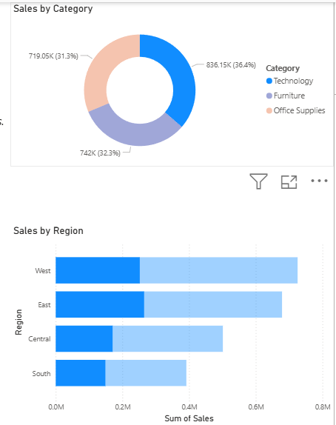

6.Write 3 short insights (example: “West region had the highest sales in Q3”)

